**Wrapper Classes**

**A Wrapper class is a class whose object wraps or contains primitive data types. When we create an object to a wrapper class, it contains a field and in this field, we can store primitive data types. In other words, we can wrap a primitive value into a wrapper class object.**

**The classes in java.util package handles only objects and hence wrapper classes help in this case.**

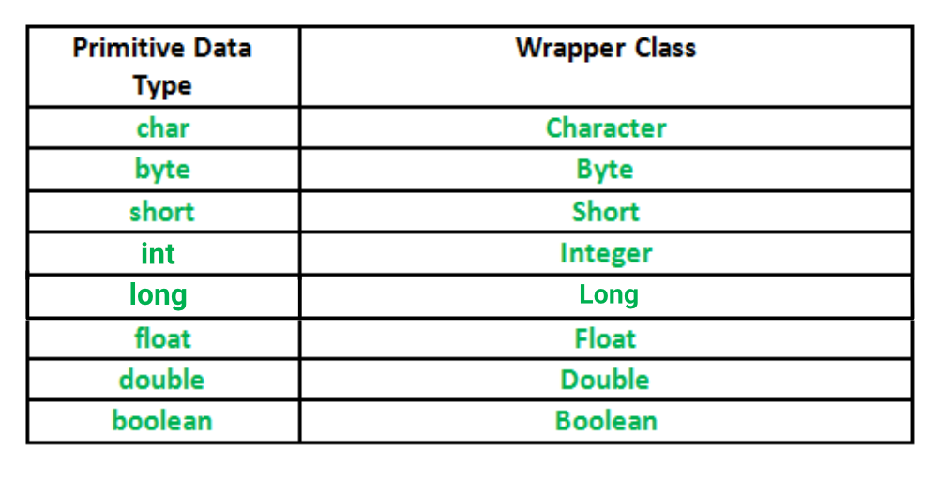

**Autoboxing: Automatic conversion of primitive types to the object of their corresponding wrapper classes is known as autoboxing. For example – conversion of int to Integer, long to Long, double to Double etc.**

**Unboxing: It is just the reverse process of autoboxing. Automatically converting an object of a wrapper class to its corresponding primitive type is known as unboxing. For example – conversion of Integer to int, Long to long, Double to double, etc.**

**Wrapper.java**

**package** p1;

**public** **class** Wrapper

{

**public** **static** **void** main(String[ ] args)

{

// autoboxing

Integer obj1 = 10;

String str = obj1.toString( );

System.***out***.println("Object 1 ="+obj1+" String object ="+str);

**int** x = Integer.*parseInt*("100");

**float** y = Float.*parseFloat*("152.45f");

**double** z = Double.*parseDouble*("167.93d");

System.***out***.println("x = "+x+" y = "+y+" z = "+z);

Integer obj2 = Integer.*valueOf*(1000);

Float obj3 = Float.*valueOf*(162.54f);

Double obj4 = Double.*valueOf*(24.55d);

System.***out***.println("obj2(Integer) = "+obj2+" obj3(Float) = "+obj3+" obj4(Double) = "+obj4);

**int** a = obj2.intValue( );

**float** b = obj3.floatValue( );

**double** c = obj4.doubleValue( );

System.***out***.println("a = "+a+" b = "+b+" c = "+c);

obj1=10;

//unboxing

**int** q=obj1;

System.***out***.println("z="+q);

}

}